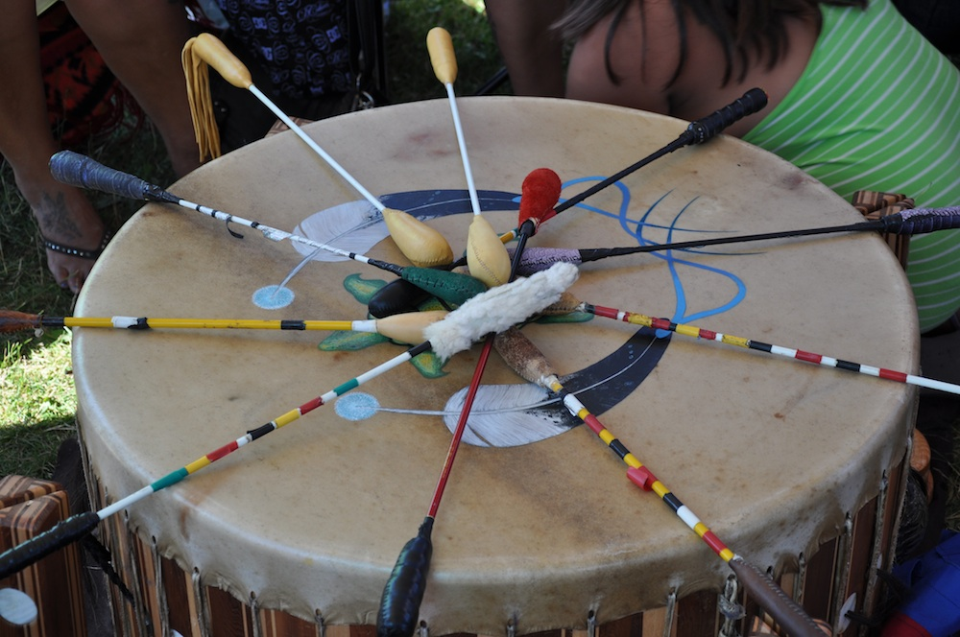[](http://www.google.com/url?sa=i&rct=j&q=&esrc=s&source=images&cd=&cad=rja&uact=8&ved=0ahUKEwi0x-CEnLnUAhUIzmMKHWE4CBgQjRwIBw&url=http://www.uk-da.com/navajo-border-clip-art.html&psig=AFQjCNHI_Dw6ZfF0aU_0GUh4pgmeuHrzcw&ust=1497388091866215)

June 29, 2023

From 6:00 p.m. to 9:00 p.m.

At M.F.C.S.

Host Drum Groups: Thunderhouse & Black Storm Crossing

“Drums of Summer”

Many Farms Community School

Presents